Customer Spending Analysis & Credit Card Strategy for Mitron Bank
Created by: Debdatta Mukherjee
Tool Used: Power BI

Introduction:
Mitron Bank aims to launch a new line of credit cards to expand its product portfolio.
To support this initiative, AtliQ Data Services analysed online spending behaviour of 4,000 customers across five major Indian cities. The objective is to provide actionable insights that help design the right credit card offerings for different customer segments.

Business Problem:
The key challenges faced by the bank include:
- Identifying high-value customer segments
- Understanding spending behaviour across categories, cities, and demographics
- Measuring income utilization capacity
- Determining demand for premium vs. basic credit cards
- Understanding payment trends (UPI, debit, credit)
- A data-driven analysis is required to help the strategy team design targeted and profitable credit card products.

Project Objectives:
- Analyse customer spending patterns across categories, months, demographics, and cities.
- Measure income utilization % to understand credit appetite.
- Identify top-spending customers and segments.
- Understand payment mode preferences (UPI, credit, debit, net banking).
- Provide recommendations for designing new credit card products aligned with customer needs.

Dataset Description:
Two main tables
- Customers Table
- Spends Table
Data Characteristics
- 4,000 customers data
- 6 months of spending data (May–October)
- Multiple spending categories & payment types

Data Model:
A simple star schema was created.
The customer_id column forms the primary relationship.
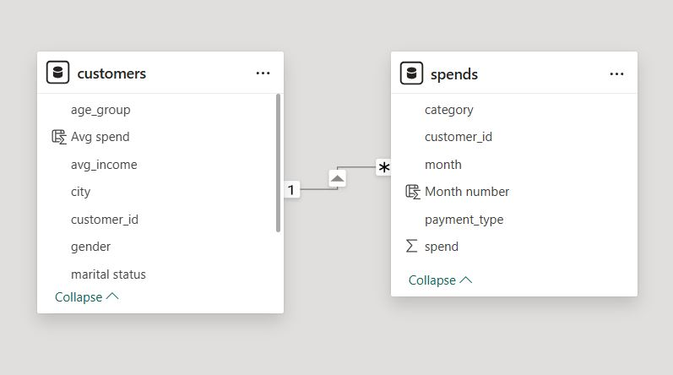

Dashboards:
Demography Dashboard
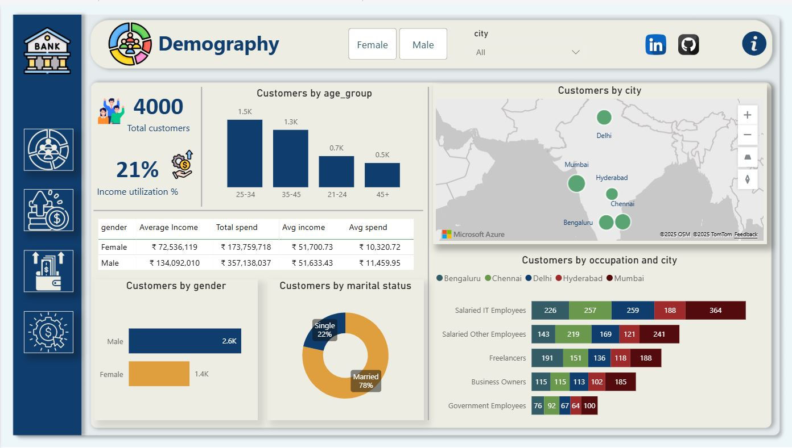

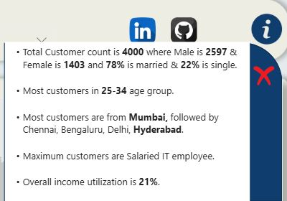
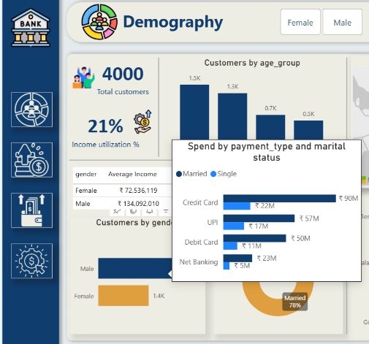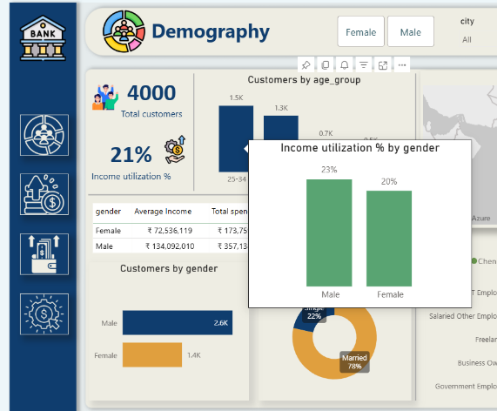
1Insights of Demographic Dashboard

Income Analysis Dashboard
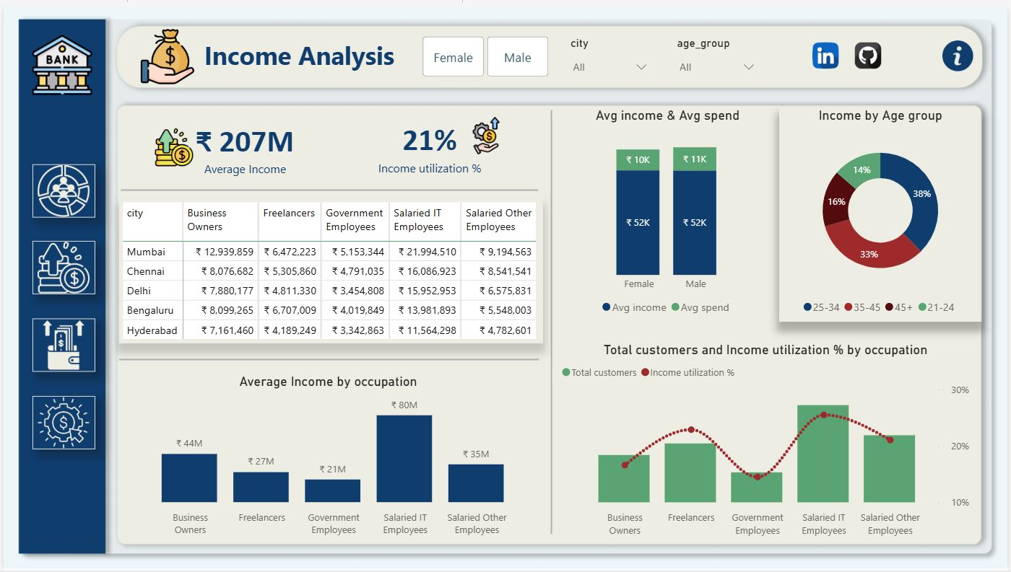
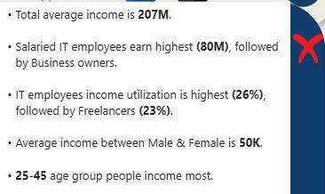
2 Income analysis insights
Spend Analysis Dashboard
